Task10

Q: Valid Anagram, given two strings s and t, return true if it is an anagram of s, and false otherwise. An Anagram is a word or phrase formed by rearranging the letters of a different word or phrase, typically using all the original letters exactly once.

Analysis:

* Create a function(task10) with two parameters.
* Check the length of the given two strings. If it is not be a same length return false, because strings are different lengths cannot be anagrams.
* Next, create obj and store the counts.
* After filling the character count in obj, the function compares the character counts between the two strings. If any character count in the first string does not match its count in the second string, the function returns false.
* Next, the character counts of the first string and checks if each character count matches its counterpart in the second string. If a mismatch is found, the function returns false, otherwise, it’s check the next character.
* the above steps are completes the comparison loop without finding any error in character counts, it returns true.

Flowchart:

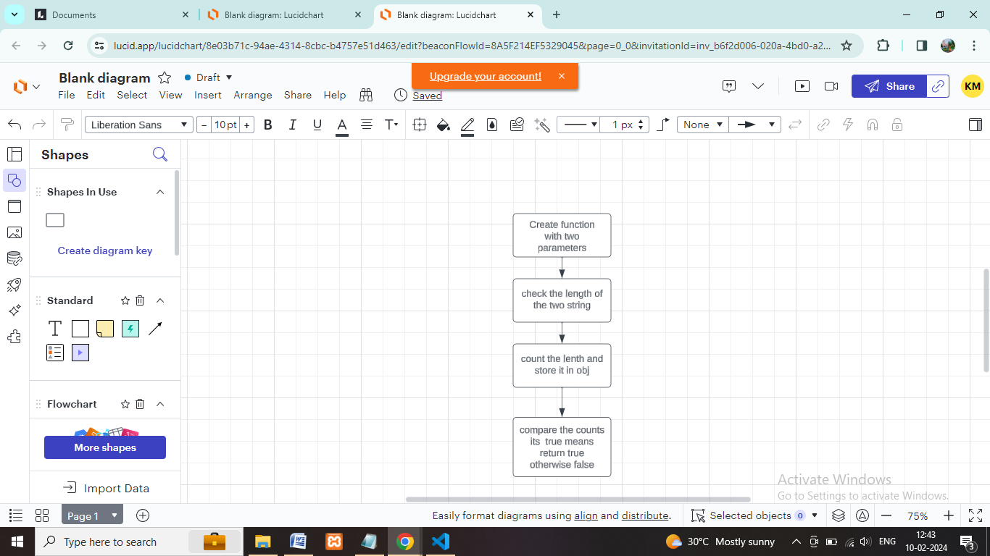

Coding:

function task10(s, t)

{

if (s.length !== t.length)

{

return false;

}

const CountS = {};

const CountT = {};

for (let char of s)

{

CountS[char] = (CountS[char] || 0)+ 1;

}

for (let char of t)

{

CountT[char] = (CountT[char] || 0)+ 1;

}

for (let char in CountS) {

if (CountS[char] !== CountT[char])

{

return false;

}

}

return true;

}

const string1 = "anagram";

const string2 = "nagaram";

const result = task10(string1, string2);

console.log("output is:", result);

Output:

